Transportation
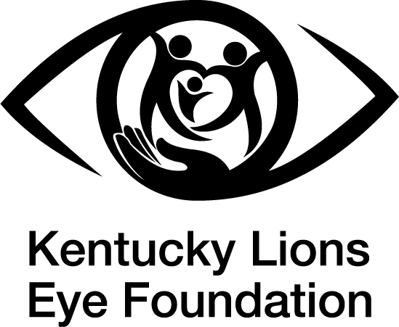
● Each state has different rules and regulations when it comes to vision and driving. The rules vary for both visual acuity and visual field.

● In Kentucky, visual requirements for driving require an individual to have visual acuity of at least 20/60 or better in at least one eye, as directed in KRS 186.578. The driver's horizontal field of vision must be at least 35 degrees to both the left and the right, and their vertical field of vision must be at least 25 degrees above and below fixation, as specified in 601 KAR 13:100.

● While many individuals with vision loss rely on family and friends to provide transportation, others rely on public transit systems.

● Many public transit systems in Kentucky follow ADA guidelines by providing accessible transportation for those with disabilities. For those with vision loss, these transit systems pick up individuals at their doorstep to help prevent navigation barriers.

● ADA Paratransit Services in Kentucky:

○ TARC Louisville KY: https://www.ridetarc.org/getting-around/tarc3/#eligibility

○ LKLP Hazard KY: https://www.lklp.org/public-transportation-2/

○ TACK Elizabethtown and Central KY https://tacktransit.org/general-public-services

○ GRITS Green River KY: https://www.audubon-area.com/transportation.html

○ TANK Northern KY: https://www.tankbus.org/ramp-paratransit/eligibility/

○ Lextran Lexington KY: https://lextran.com/accessibility/wheels-paratransit/

○ Daniel Boone Transit Eastern KY: https://danielboonecaa.org/programs/transportation

○ To find your county, visit: https://transportation.ky.gov/TransportationDelivery/Pages/Public-Transportation-Providers.aspx



This free resource is provided by the Kentucky Lions Eye Foundation. Our mission is to provide vision services through education, detection, prevention, treatment and empowerment. Through collaborative partnerships, we enable greater independence and increased quality of life for all Kentuckians while focusing on children and adults in financial need. Our Low Vision Clinic provides specialized resources and support to help individuals with vision loss maximize their independence and quality of life. To learn more about our Low Vision Clinic, please visit www.kylionseye.org/lowvision.
- Created by Molly Hosking, OTS
From Spalding University

