Accessibility on Android


● Android products have accessibility settings specific to vision impairment.

● To have the device read aloud:
○ Go to settings → Locate Accessibility tab → Locate “Select to Speak” → turn on “Select to Speak”.
○ Tap the accessibility button found on the top right of the screen→ select by touching the body of text you would like the phone to read aloud.
○ To hear multiple bodies of text, drag your finger across the screen to the desired amount of text.

● To zoom in on the screen:
○ Go to settings → Locate Accessibility tab → Locate Magnification → Turn on “Magnification Shortcut”.
○ To zoom in, tap the magnifying button found on the top right of the screen, drag two fingers to move the magnified screen, and pinch with two fingers to zoom in within the screen.

● Increasing size of text messages:
○ Go to messages app → Locate the “Account” icon → Locate Message Settings → Turn on “Pinch to Zoom Conversations”.
○ This will allow you to make text sizes smaller or larger by pinching that text with two fingers.

● Adjusting brightness:
○ Go to settings → Locate Accessibility tab → Turn on “Extra Dim”.
○ This can be turned on and off with quick settings. Swipe down from the top of your screen twice → Locate the “Extra Dim” tile and turn on or off.
○ To increase or decrease brightness on your phone, swipe down from the top of your screen twice → locate the horizontal bar → drag across the bar to the desired brightness of the screen.

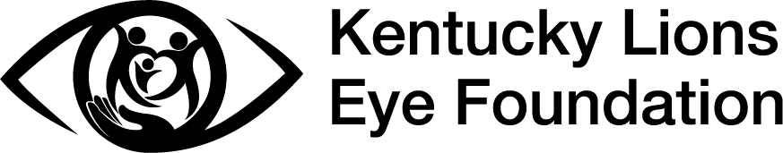

This free resource is provided by the Kentucky Lions Eye Foundation. Our mission is to provide vision services through education, detection, prevention, treatment and empowerment. Through collaborative partnerships, we enable greater independence and increased quality of life for all Kentuckians while focusing on children and adults in financial need. Our Low Vision Clinic provides specialized resources and support to help individuals with vision loss maximize their independence and quality of life. To learn more about our Low Vision Clinic, please visit www.kylionseye.org/lowvision.
- Created by Molly Hosking, OTS
From Spalding University

