Apps for Vision Loss
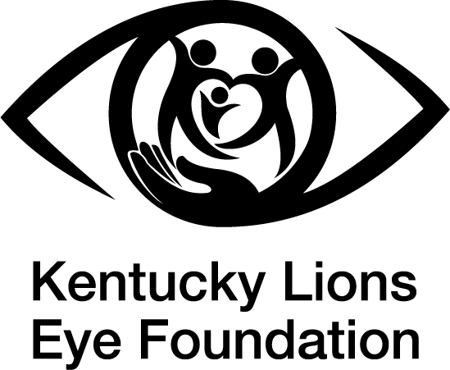

● Technology has come a long way for those who have vision loss and has met the sign of the times.

● There are now apps on iPhone/Android devices that can assist those with visual impairments in their everyday tasks, which can include item retrieval, navigation, identification, etc.

● To download apps, go to the Apple App Store or Google Play Store.

● Seeing AI
○ This free app allows users to hover their phone over a document or take a picture of a document that can be read aloud under the “Read” tab

○ The user can hold up their phone and have the app describe their environment around them under the “Describe” tab.

○ The “More” tab can perform the following tasks of reading barcodes, identifying people, reading currency, color identification, and light detection.

● Be My Eyes
○ This free app assists visually impaired individuals with skills of navigating, identification, reading, and item retrieval.

○ The app recruits either sighted volunteers or uses AI features to assist these individuals with vision loss.

○ Volunteers and AI tools are always available with the app being run 24/7 and worldwide.

● Magnifier
○ iPhone and Android devices have their own magnifier apps. The apps allow for magnification of external print and objects with the phone’s camera.

○ On iPhone, the app is already downloaded. One has to either search for the app in the search bar or ask Siri to open the app. You can also add the magnifier to your accessibility shortcut or the control center for ease of access.

○ On Android, one must download the app from the Google Play Store. From there, they can find it on their home screen or ask Google to open the app.



This free resource is provided by the Kentucky Lions Eye Foundation. Our mission is to provide vision services through education, detection, prevention, treatment and empowerment. Through collaborative partnerships, we enable greater independence and increased quality of life for all Kentuckians while focusing on children and adults in financial need. Our Low Vision Clinic provides specialized resources and support to help individuals with vision loss maximize their independence and quality of life. To learn more about our Low Vision Clinic, please visit www.kylionseye.org/lowvision.
- Created by Molly Hosking, OTS
From Spalding University

